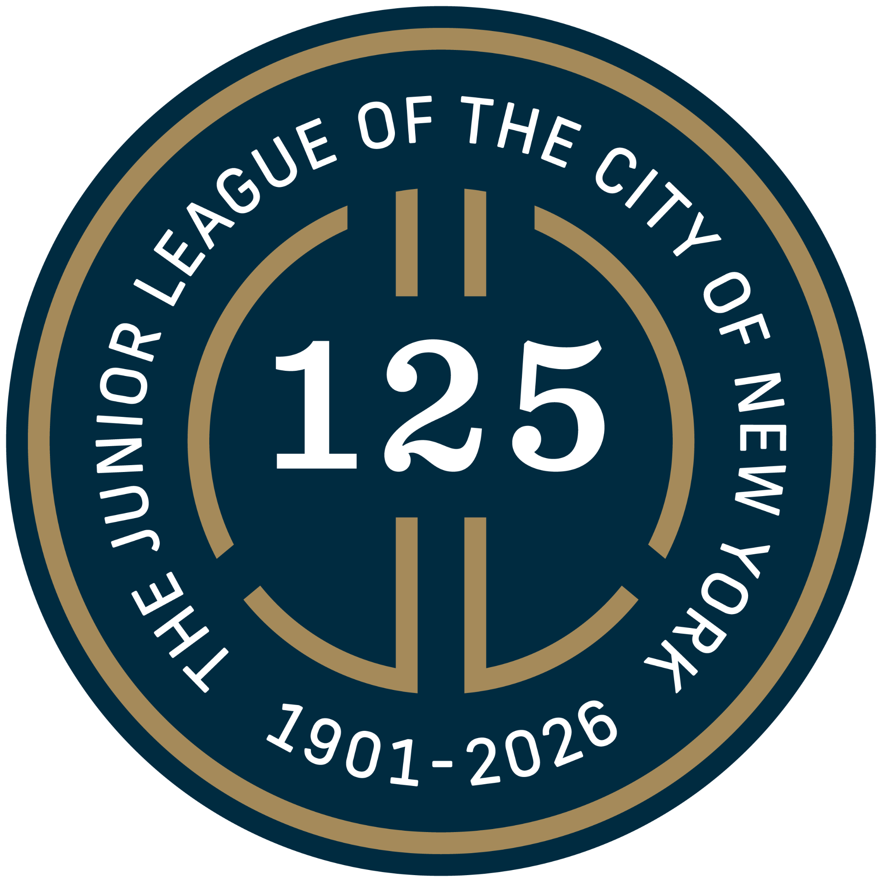

New York Junior League Report Calls for New Funding Models and Sector-Wide Coordination Network, Finds Demand on NYC Nonprofits Surging
Landmark 125th anniversary report highlights frontline voices, identifying systemic failures facing the human services sector

New York, NY — June 23, 2026 — With living costs surging in New York City, too many families have been left struggling to make ends meet and reliant on a human services sector pushed to the brink. A landmark report released today by the New York Junior League (NYJL) identifies the systemic challenges and opportunities for government and private funders to support the city’s critical human services infrastructure.

Marking the nonprofit’s 125th anniversary, Bridging the Gaps: Strengthening NYC's Human Services Infrastructure for Families and the Future draws from a city-wide survey, executive interviews, and a community forum with the city’s leading nonprofits and community organizations. Opening with an interview between Jeri Powell, NYJL President, and Kathryn Wylde, former President and CEO of the Partnership for New York City, the report addresses how leaders should address critical funding needs, rapid technologization, and a fragmented services system. Key findings include:
- 91% of organizations surveyed reported demand for services increased or stayed the same over the past 12 months.
- Rapid technologization has the potential to address longstanding administrative challenges and under resourcing, but funding limitations have left the sector navigating one of the most significant technological shifts in human history without guidance or the resources to do so.
- Over half of respondents identified housing instability as the most critical need facing the families they serve, followed by food insecurity and healthcare access.
- Organizations reported that inadequate funding and rising costs ranked as their top two operational challenges, with many citing restricted contracts and delayed payments as leaving them unable to invest in core operations, staffing, community spaces, and technological development.
- As medical advances successfully extend lifespans and create growing populations of survivors, nonprofits need support to address complex, interconnected long-term needs without compromising their mission.

“In New York City, our human services organizations are the core infrastructure that keeps this city moving. As we face rising unemployment due to automation as well as the forthcoming federal cuts to SNAP, Medicare, and Medicaid, we must act now to address key systemic challenges that hold back our nonprofits from operating at the scale and effectiveness New Yorkers need and deserve,” said Jeri Powell, New York Junior League President. “This is a critical opportunity to rethink how we deliver funding and scale technology to help organizations serve our neighbors with compassion and purpose.”

One of the city’s oldest nonprofits, the NYJL was founded by a group of college students in 1901 with a simple vision: That trained women volunteers can lead change in their communities. Those early volunteers in settlement houses soon expanded their support across the city, from establishing the first volunteer program in an NYC hospital outpatient department and creating playgrounds on vacant lots to pioneering awareness campaigns for Alzheimer's and successfully advocating for landmark social media protections for children. Powered by more than 2,800 women volunteers today, the NYJL trains women to lead programs and advocate for New York’s women, children, and families in partnership with more than 60 community-based organizations.

What began on the streets of New York has since grown to 292 chapters across four countries. Among Junior League members number First Lady Barbara Bush; First Lady Laura Bush; chef and author Julia Child; First Lady Betty Ford; Academy Award-winning actress Katharine Hepburn; first U.S. Secretary of Health, Education, and Welfare Oveta Culp Hobby; CEO of Ingram Industries Martha Rivers Ingram; U.S. Representative Carolyn Maloney; aviation pioneer Ruth Rowlands Nichols; Supreme Court Associate Justice Sandra Day O'Connor; First Lady Nancy Reagan; First Lady Eleanor Roosevelt—who brought her future husband, Franklin D. Roosevelt, with her to volunteer in the settlement houses, a time both credited as inspiring their later social reform action—Olympic gold medalist Kerri Strug; and actress, ambassador, and Chief of Protocol of the United States Shirley Temple Black.

The report draws on insights from organizations across all five boroughs, including All Souls NYC; Arts NYS; Catholic Charities of the Archdiocese of New York; Center for Family Life in Sunset Park; Citymeals on Wheels; Commonpoint; Community Help in Park Slope (CHiPS); The Domestic and Other Violence Emergencies (DOVE) Program, New York Presbyterian Hospital; Esperanza Preparatory Magnet School; Executive Nurse Leadership Network; Franciscan Bread for the Poor; Global Kids, Inc.; God's Love We Deliver; Good+Foundation; Harlem School of the Arts; Health Advocates for Older People; Henry Street Settlement; Hour Children; JASA; Korean Community Services of Metropolitan New York, Inc.; Lenox Hill Neighborhood House; Loisaida, Inc.; Minds Matter NYC; New York Common Pantry; NYC Autism Charter Schools; New York City Department of Parks & Recreation; New York City Department of Social Services; Order of Malta American Association, NYC Area; Project Cicero; Randall's Island Park Alliance; Red Door Community; Rising Ground; SHARE Cancer Support; Single Parent Resource Center, Inc.; St. John's Bread and Life; St. Joseph's Soup Kitchen; The Bowery Mission; The English-Speaking Union; The HOPE Center; The New Jewish Home; The Opportunity Network; The Red Door Place; University Community Social Services; University Settlement Society of New York; Urban Pathways; and Working in Support of Education (W!se).

Read the report.

About the New York Junior League
Since 1901, the New York Junior League (NYJL) has responded to New York City’s most pressing socioeconomic challenges. Powered by more than 2,800 women volunteers, the NYJL works with more than 60 community-based organizations to advance children’s social-emotional learning and to provide life skills programs to youth and adults who are navigating periods of difficult transition. Bringing their diverse experiences and talents, trained NYJL volunteers engage women and children in health, education, and arts workshops specially customized to their needs. The NYJL also advocates with state and city government for women- and children-centered policies and develops volunteers’ leadership skills for service in the NYJL and on other nonprofit boards, all while cultivating a community that reinforces women’s personal relationships and collective power as drivers of positive change. Learn more at nyjl.org.

Media Contact: press@nyjl.org
Media Kit

