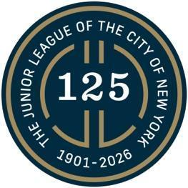

February 10, 2026 CONTACT: press@nyjl.org

The New York Junior League Rings the NYSE Closing Bell to Launch 125th Anniversary Year

New York, NY - The New York Junior League (NYJL) proudly rang the Closing Bell at the New York Stock Exchange on Thursday, February 5, 2026, marking the official start of the organization’s 125th Anniversary year.

NYJL President Jeri Powell was joined by Past Presidents and members of the Board of Directors, Management Council, and the 125th Anniversary Task Force for this milestone moment, celebrating 125 years of service, leadership, and impact across New York City.

During the ceremony, Powell expressed gratitude to the New York Stock Exchange for its warm welcome and commemorative gift, noting the significance of gathering at such an iconic institution to mark the League’s anniversary year. “We were delighted to gather with the NYSE to celebrate the enduring spirit of volunteerism and our organization’s remarkable legacy,” Powell shared.

Powell reflected on the generations of members whose dedication has strengthened the NYJL and advanced its mission over more than a century, emphasizing that this milestone anniversary is a testament to the collective impact of volunteer leadership. “There was no better place to kick off this anniversary year than the New York Stock Exchange,” Powell added. “We are grateful for the opportunity to begin this milestone in a setting that so powerfully represents New York City’s history, leadership, and global influence.”

Founded in 1901, the New York Junior League is one of the oldest, largest, and most influential women-led volunteer organizations in the world. For 125 years, the NYJL has responded to the evolving needs of New York City through hands-on community initiatives, advocacy, and the development of civic leaders committed to improving the lives of women, children, and families.

The ringing of the NYSE Closing Bell marks the first of many moments planned throughout 2026 to commemorate the NYJL’s 125th Anniversary and to celebrate the volunteers whose service has shaped — and continues to shape — the organization’s enduring impact.

####

