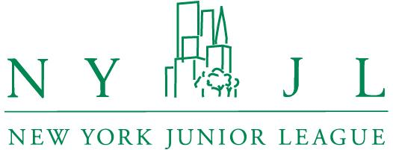
Media Contact:
Megan Zuckerman
press@nyjl.org
848-448-2728

Governor Hochul, NY State Senator Krueger, Congresswoman Maloney Join
New York Junior League in Support of the Equal Rights Amendment
NYJL Hosts Panel Discussion on Women’s Health Equity
New York, New York (October 23, 2024) – The New York Junior League (NYJL) hosted its annual Legislative Breakfast today, focusing on women’s health and equality while raising awareness for the New York State Equal Rights Amendment, on the ballot this November as Proposition 1. New York Governor Kathy Hochul delivered keynote remarks alongside New York State Senator Liz Krueger (D-NY-28), co-sponsor of Proposition 1. The event closed with remarks from Congresswoman Carolyn Maloney (D-NY-12, 1993-2023).
Additional participants included New York State Senator Andrew Gounardes (D-NY-26), U.S. Department of Labor Assistant Secretary Lisa M. Gomez; India Sneed, Esq., Founder & Managing Partner, IQEQ Law PLLC; and Dr. Henry Love, PhD, Vice President of Policy and Planning at Win. Also in attendance were Assemblymember Alex Bores (D-NY-73), Executive Director of the NYC Council's Women's Caucus Thamar Ferdinand, and Assemblymember Grace Lee (D-NY-65).
“The New York Junior League was pleased to host this very important convening of city, state and federal leaders focused on women’s health and equality,” shared NYJL President Jeri Powell. “For nearly 125 years, we have stood at the forefront of advocating for the women, children and families of New York City. With nearly 2,500 trained women volunteers, we will bring the full force of our resources to the cause of improving women’s health and equality by advocating for laws that ensure and enshrine every human’s ability to reach their full potential.”
The NYJL’s Advocates for Public Policy committee champions legislation and policy initiatives in support of the NYJL’s work for women, children, and families in New York, including women’s health and equality, mental health equity, poverty relief, and domestic violence.
Learn more about how to support the programming of the NYJL.
About the New York Junior League
Since 1901, the New York Junior League (NYJL) has responded to New York City’s most pressing socioeconomic challenges. Powered by nearly 2,500 women volunteers, the NYJL works with more than 60 community-based organizations to advance children’s social-emotional learning and to provide life skills programs to youth and adults who are navigating periods of difficult transition. Bringing their diverse experiences and talents, trained NYJL volunteers engage women and children in health, education, and arts workshops specially customized to their needs. The NYJL advocates with state and city government for women- and children-centered policies and develops volunteers’ leadership skills for service in the NYJL and on other nonprofit boards, all while cultivating a community that reinforces women’s personal relationships and collective power as drivers of positive change. The NYJL also responds to community partners’ requests for immediate support and invests funds and volunteers’ time in restoring public parks and community spaces to create welcoming environments conducive to fitness, health, recreation, and socialization.
www.NYJL.org
www.facebook.com/thenyjl
www.instagram.com/thenyjl
www.twitter.com/thenyjl

